1451: SIENA − NEW LAWS AGAINST GAMBLING
Franco Pratesi − 24.04.2012

Introduction

In the history of card games in Italy, a significant contribution has derived from the study of the statutes of our communes. This is not a rewarding research, because we usually obtain at most some names of forbidden games, which were considered at the same level as dice games.
We can be more fortunate in rare cases, in which among all other games, considered as prohibited, a few ones are quoted as allowed. It was thanks to his kind of information that I could report how four card games (Diritta, Vinciperdi, Trionfi, and Trenta) were explicitly allowed, for the first time, in the Florentine law of 10 December 1450. (1) Some of these games, and others, I found mentioned later on, when studying the statutes of several minor communes of the Florentine territory. (2)
Taking up these studies again after a long interval, I could recently report that the same new law instituted in Florence in 1450 had been directly inserted, after a short time, also in the statute of Gambassi. (3) In particular, this appeared to be an interesting additional information on the early spread of the game of Trionfi, present by then not only in the chief town, but also far away, in the countryside.
In the last months I am carrying out a similar research in the Archivio dello Stato di Siena (ASSI). In comparison with Florence, this research is similar for its objectives, but there are significant differences. Here I give some preliminary information and focus then my attention on a particular law, as can be read in one of the statutes examined.

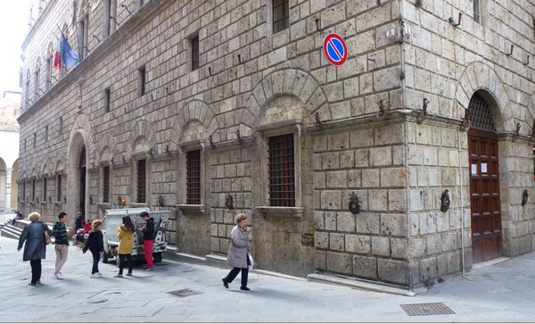

Figure 1 –Archivio di Stato di Siena.

Florence, Siena, and their statutes

In the middle of the 15th century, when Florence had already conquered most communes of North-Tuscany, Siena had done the same with those of South-Tuscany. Of course, there was a greater trade and manufacturing activity in Florence, but the two big territories were independent and only a century later on, with the conquest of Siena, Florence became the chief town of a Grand Duchy, in actual practice unifying the whole of Tuscany (apart from small exclusions).
In the 15th century, we still find Siena as the chief town of a big territory, rivalling with neighbouring Florence. Siena had obviously its own Statuti, which were updated and modified up to 1545, the last one coming from its independent commune.
There are no less than 68 books of Siena statutes in ASSI (by chance, exactly twice as many as the Florence statutes in ASF) with specimens of various dates. They have been mostly published and I did not hope to find there important new information for the history of card games.

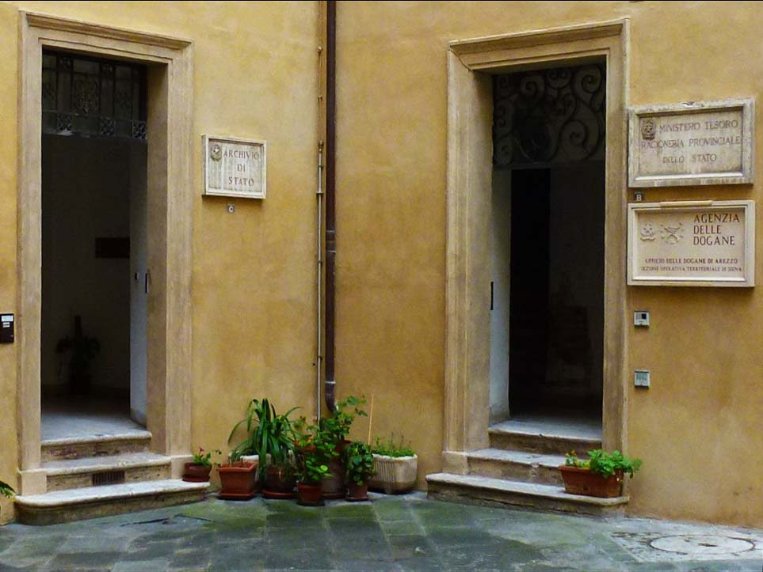

Figure 2 – The “wrong” entrance to the ASSI, on the right.

Let me just remind a couple of data, which are already known: a) the early Sienese Provvisione of 6 November 1377, only a few months later than the Florentine one (23 March 1377), forbidding the “new” naibi game, and, at the other limit, b) the games allowed in the Statuto of 1545, (4) with the curious (for us) spelling of Bermini instead of Germini in its printed form: tavole con dadi, alle minchiate, alli bermini, alli trionfi, al dritto, al diavolo, al trenta, al poi, a criccone, a ronfa, a farinaccio. The distinct presence here of Germini, Minchiate, and Trionfi leaves us with hard questions to answer: whether these three games really were one, two, or three different ones, and whether they could be played with the same pack.
Let me avoid now to discuss further these and similar questions and limit my attention to the middle of the 15th century, in the hope that, one century earlier, our matters were not yet so intricate.

Statuti dello Stato senese

I have focused my attention on the statutes of the minor communes of the Siena territory. In Florence, we find in the ASF almost one thousand Statuti delle comunità autonome e soggette, mostly unpublished. The corresponding section in Siena only has 157 books. A large fraction of them has its oldest contents only beginning in the 16th century, or afterwards. Moreover, a great part of the statutes of our interest, i.e. containing laws of the 15th century, have been published, more or less recently, in the form of printed books, with the full text and many explanations.
Apparently, there has been a remarkable interest in these books by local experts in recent times. This is of course a commendable circumstance; however, a printed book can be found and studied anywhere and I do not need to visit the ASSI in order to read these statutes, already in printed form − even if I must admit that finding them in the library of the ASSI is much easier and faster than anywhere else.
I am not sure that I will ever write a report on these statutes. There is however another law that I want to report at once – as I have done for the game Le Corone in the statute of Massa Marittima some time ago. (5) Now, the statute involved is that of Asinalunga. (6)
Asinalunga is the name that this small town had at the time – later on, it has been changed into Sinalunga. This commune is in a strategic position, almost at the same distance from Siena and Arezzo, and also not too far from Perugia. In the time under examination, the territory of Siena was divided into eleven vicariati, and Asinalunga was the chief town of one of them, at the NE border of the territory. (7)

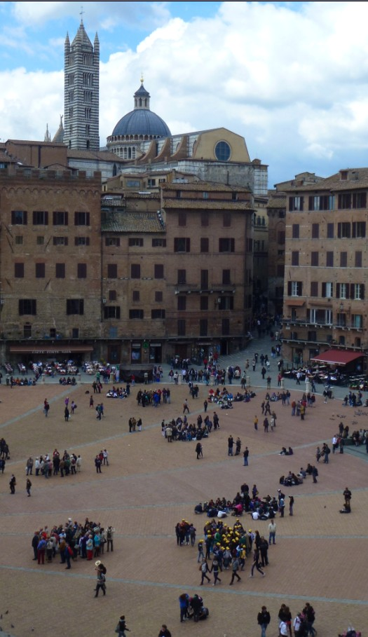

Figure 3 – Piazza del Campo, view from the ASSI.

In reading the statute, I found that its first complete version is missing, and the book consists in many reforms, starting from 1443. Particularly interesting for me has been a Provvisione of a few years later, which I am reporting here. When I first read it, I supposed that it had been inserted in the statute of Asinalunga by the local statutari, as for most of the laws added there in the course of time.
It was rather surprising to find such a detail in the laws on gambling of a small commune, but this was not an impossible situation. Only in a second time, I have clearly seen that this law was a law of the Siena commune itself and had been inserted in the statute of Asinalunga, just in the same way as the law of Florence had been inserted in the statute of Gambassi.
If we are able to see the situation with optimism, we may even be glad of this oversight, because it is as “to kill two birds with one stone”: we get the law promulgated in Siena, and at the same time we obtain the confirmation that it was soon adopted in smaller communes of the countryside – which can also be presumed as indicating that these games, allowed by the law, were already the object of a widespread practice.
Now, we are ready to examine the whole law, and defer to a following section its search in Siena itself.

Provvisione − full text

Before reading the Provvisione, some information may be useful. Let me first comment on the text, as for its writing. Many words could have been slightly modified in order to conform to the correct spelling of nowadays, or even of those days. I did not change anything, except for adding accents and several punctuation marks (to transform all the paragraphs in a fluent text, a deeper intrusion would have been necessary, too much for me). Moreover, I added the initial numbers from 0 to 9, in order to obtain an easier connection with the following section.
For anybody intending to study similar documents, reading and understanding this one, in every detail, may represent a useful training.

0) Anno Domini Mccccl Indictione xiiii. Die vero xii mensis marçii. In generali consilio communis et populi Magnifici communis Senarum solepniter convocato fuerunt victe et obtente infrascripte provisiones quarum tenor est infrascriptus, videlicet:
1) In prima che niuna persona di qualunche stato o conditioni si sia della città contado o distritto di Siena possi o presuma giocare a gioco di dadi o veramente di carte o naybi sotto la pena di L.xxv di denari per ciaschuna volta che contrafacesse da applicarsi al communo di Siena e fatta la detta codenpnagione inmediate qualunche offiçiale avesse cognosciuta o fatta essa condenpnagione sia obligato sotto la medesima pena ad significarlo in biccherna et alo spetchio intendendosi che durante la descriptione di detta condepnagione al detto specchio sia et essar s’intenda essare tractato come gli altri che sono scripti al detto spetchio sicondo l’ordini et statuti del comune di Siena.
2) Item che ciaschuno chi giocasse a detti giochi prohibiti o ad alcuno dessi in luoghi secreti o in casa o in altri luoghi occulti debba essare condenpnato per ciascuna volta nel doppio della sopradetta pena da essare descripto in bicherna et alo spetchio ne modi sopradetti et sotto la medesima pena al’offitiale che in ciò fusse negligente. Salvo niente di meno che le predecte pene e condenpnagioni non abbino luogho contra di chi giocasse a tavole con dadi et a naybi o carte a questi giochi cioè al dritto a vince perdi al trenta et a triomfi et in altri modi s’intenda essare prohibiti.
3) Item che nelle predette cose et contra le predette cose il podesta capitano della giustitia regulatori et offitiali della mercantia della città di Siena possino et debbino congnosciare et procedere contra tali giocatori sotto la sopradetta pena et di fuore della città ciascuno offitiale possi et debba cognosciare punire et condenpnare come di sopra è ordinato intendendosi essare reserbata la cognitione a quello offitiale che prima prevenisse o a procedare cominciato avesse et possino congnosciare et procedare per inquisitione et accusa come vedrano essare più conveniente.
4) Item che della predetta pena et condenpnagione la terça parte sia et essare s’intenda dell’offitiale del quale farà la detta condenpnagione l’altra terça parte al comune di Siena et l’altra terça parte all’accusatore et questo quando el detto offitiale arà rischossa la detta condenpnagione et in verità facta venire nelle mane del camerlengho del monte del comune di Siena.
5) Item che a ciaschuna persona sia lecito accusare, et dinunptiare quelli che giuocano a detti giuochi prohibiti et seli data piena fede quando tale accusa provarà per due testimoni et quali giurano avere veduti giuocare et i nomi di tali accusatore per li detti offitiali sia tenuto secreto sotto pena di L.1 per ciaschuna volta che contra facesse.
6) Item che qualunche persona giuocarà a detti giuochi prohibiti et accusarà et denunpciarà quello o quelli che con lui giuocaranno a detti giuochi s’intenda essar libero et absoluto dala condenpnagione et pena nella quale era incorso per lo detto giuocho et abbi anchora la terça parte della detta condenpnatione come di sopra è detto.
7) Item che se alcuna persona giuocarà ad alcuni de detti giuochi vietati et ad quello giuocho perdarà alcuna quantità di denari o d’altre cose che al detto perditore sia lecito et possi in termine di sei mesi dal dì della detta perdita dinançi a qualunche de detti offiçiali quello arà perduto adimandare al vincitore doversi a lui restituire et ciascuno de detti offiçiali sia tenuto et debbi trovata la verità del facto pronunptiare et condenpnare il detto vincitore a rendere et ristituire al detto perditore le dette cose vinte le due parti et l’altra parte sia desso rettore et offiçiale che farà l’executione. Et se accadesse che il detto perditore le dette cose perdute non volesse adimandare che sia lecita al padre madre figliuoli et fratelli carnali çii et nipoti carnali e la moglie desso perditore tale cose perdute adimandare et cognosciuta la verità del facto e detti offitiali e rettori sieno tenuti a farle a loro ristituire le due parti et l’altra parte sia dessi offitiali come di sopra è detto.
8) Item che qualunche persona per li detti giuochi vetati sarà condepnato pagandolo in termine di quindeci dì da poi che sarà condenpnato possi pagare il terço meno et si confessarà spontaneamente tale excesso overo giuocho avere commisso pagando infra il detto termino la mettà dessa condenpnagione sia libero et absoluto dell’altra mettà et dal detto termino in là non pagando possi essare constretto in persona et in avere a pagare interamente la detta condenpnagione da essare descripta et distribuita ne modi sopradetti per la quale condenpnagione non li posse essare conceduti alcuno salvo conducto o altra sicurtà et essendoli conceduta non gli vaglia per alcuno modo.
9) Item che qualunche persona ricettarà alcuno de detti giuochi prohibiti in alcuna sua casa o in alcuno suo luogho proprio o conducto caggia nella pena del doppio di quello che è ordinato di sopra contra quelli che ad essi giuochi prohibiti giuocassero da distribuirsi et discriversi come di sopra è scritto e detto. Et in simile pena incorra qualunche persona prestarà vendarà o donarà per alcuno modo dadi carte e naybi per giuocare a sopradetti giuochi prohibiti avendone legittime prove come di sopra è detto del giuocho et tutte le sopradette cose s’intendino per li forestieri come per li cittadini di Siena. Et vincendosi et obtenendosi la sopradetta provisione sieno tenuti i regolatori in termine di quindeci dì di farla publicamente bandire et insinuare in tutti li statuti che stanno presso a sopradetti offitiali et comita del contado di Siena per fante propio al spese del comune di Siena che ciaschuno simile mente la faccia bandire et observare ne modi sopradetti.

Provvisione abridged

These laws were mostly compiled in dog-Latin, remarkably different from the language of the classical literature of Rome. We are slightly fortunate to have only its introduction left, with all the following chapters translated into dog-Italian. I fear that the progress in understanding can only be significant for people who have Italian as mother tongue, and are moreover somewhat accustomed to read it in the ancient texts too. (For example, Word does not accept most of these words and is ready to suggest alternative spelling, usually even worse.)
The text in both languages can be read in the previous section. Here, let me try to provide interested readers with a much abridged version in dog-English, more widely understandable.
0) This introductory part keeps the original Latin language. Here we read that it is Indizione 14th of the 12 March 1450 − because of the New Year fixed on the 25 March, as in Florence, we have to read this as 1451. The general council of the commune and people of Siena solemnly convoked promulgates a Provvisione. The conclusion is that the law approved had about the text and the meaning reported in the following points, which we read in the book in Italian.
1) Together with dice games we find prohibited cards or naybi games, both in the town and outside. It may be of some interest the unusual spelling of naibi with a “y”, and especially the identity implied between carte and naybi. The fine of L.25 is high, about a dozen times higher than the 40s. that were used in other places. Officials must impose that fine (if not, they are fined in the same way) and insert the data in the books Biccherna and Specchio of the administration of the Siena commune.
2) The fine stated above has to be doubled in case that the game had taken place in closed places, within the houses, or in any private place. Then we find the most important point for us - where “our” games are listed: all the fines mentioned should not be applied «contra di chi giocasse a tavole con dadi et a naybi o carte a questi giochi cioè al dritto a vince perdi al trenta et a triomfi», against players of tables with dice, and these card or naybi games: Dritto, Vince Perdi, Trenta, Triomfi. Exactly the same four games as in Florence.
3) The officials can search and must know and punish the gamblers; also out of the town they can avail themselves of charges and inquisitions, at their choice.
4) The money coming from the fine, as soon as it has been forwarded to the head of the cash department of the commune, has to be divided into three parts: one to the official who imposed the fine, one to the commune, one to the informer.
5) Heads of the police and officials of merchant corporations shall be informed of violations within the town and also outside. They must trust in any informer, supported by two witnesses, who swear to have seen the gamblers at play. The name of the informer must be kept secret, otherwise the officials are fined L.1 for each occurrence.
6) Any gambler who denounces his gambler partners is absolved from his part of the fine and moreover obtains one third of the fine paid by his partners.
7) Anybody who loses money or anything else at the games prohibited has a six-month time to ask for the whole amount back. This right of the loser is extended to any of his relatives (father, mother, children, uncles, nephews, wife). It is a task of the officials to ascertain the facts and to force the refund. One third of the amount refunded goes to the officials.
8) If the fine is paid within 15 days, it can be reduced to two thirds of the original amount. If a gambler confesses spontaneously, he only pays half of the fine due (if within 15 days – if later, no reduction is admitted).
9) Anybody who consents gambling activity in his house or in any of his possessions must be condemned to the double of the fine. The same for anybody who supplies, in any form, the game sets, either dice or card packs.
Within 15 days, the new law must be announced in public by a crier paid by the commune of Siena, adopted in the town and in any part of its territory, inserted in the statutes, and obeyed in the ways described.

Provvisione in Siena?

As I have explained before, I did not yet study the various manuscripts of the statutes of Siena itself. There are at least three of them (No.39, No.40, and No.47) that may contain the law under examination, and I intend to examine them sooner or later. However, something I have already examined, which has been enough to convince me to report and discuss here the law described above.
In Florence, we have several collections of Provvisioni, the laws created in the course of time by the government. In Siena, they seem not to have kept a systematic collection of these early laws. There are however at least two archives in which they can be found, Consiglio generale, and Concistoro.
Taking the date into account, two appear to be the best candidates, Concistoro 1592 and Consiglio generale 285. In the former, I found nothing of interest. In the latter, however, I found information enough to convince me to publish the law. (8)
The official notary records there the essential decisions of the council during Indizione 14th of 12 March 1450 (1451 for us), exactly that found in Asinalunga. They approved four Provvisioni and the contents of the second of them are the same as reported above. Unfortunately, its full text is not present there, but only a short Latin summary. «Secunda provisio continent… non possit ludere ad ludum taxillorum cum multis aliis partibus et clausulis.»
As a result, so far I could not find the whole text of the Provvisione in Siena, but I found the statement that this law had been delivered on that day, and that it was very detailed, with many parts and clauses – exactly as we could read in Asinalunga.

Conclusion

In the territory of Siena, the minor communes compiled their own statutes, usually taking those of the chief town into account. We are especially interested in the laws against gambling and in the names of particular card games that we can find there, either forbidden or allowed.
Here a complete law, with much detail, is reported from the statutes of Asinalunga (now Sinalunga). This is a law of 12 March 1451, which had been directly composed and approved by the general council of the Siena commune. The most interesting entry for us is that four card games were allowed: Dritto, Vince Perdi, Trionfi, and Trenta. They are exactly the same games that had been allowed in Florence in the previous year, even though at the time between Florence and Siena there was much more hostile rivalry than friendly emulation.
I have not yet found a full record of this law among the Siena documents, but the fact that we can read it in the statute of Asinalunga has the advantage to show (as it had occurred at Gambassi) how these games in 1451 had already spread into the countryside too.

Notes

(1) The Playing-Card, Vol. XIX No. 1 (1990) 16.
(2) The Playing-Card, Vol. XVIII No. 4 (1990) 128-135. http://trionfi.com/card-playing-laws-florence
(3) The Playing-Card, Vol. 40 No. 3 (2012) 167.
(4) Mario Ascheri, L’ultimo statuto della repubblica di Siena (1545). Cantagalli, Siena 1993.
(5) http://trionfi.com/corona-le-corone; ASSI, Statuti dello Stato, 64, 9, l. 48
(6) ASSI, Statuti dello Stato, 9, l. 48r-49r.
(7) http://it.wikipedia.org/wiki/Sinalunga
(8) ASSI, Consiglio generale, 285, l. 1v.

