1829-1840: FLORENCE − PLAYING CARDS AT COCOMERO
by Franco Pratesi – 10.11.2013

INTRODUCTION

A first note dealing with card playing in the Stanze of Teatro del Cocomero informed on the years 1799-1807. (1) It contained all the basic references to the place and to the archival documents available for study in the ASCFI; they will not be repeated here. A second note on the same subject has continued the description up to 1829. (2) Now, the report is extended to the year 1840.
As for the general political situation, no great changes were occurring in the years under examination, differently from the previous time intervals. As rulers of the Grand Duchy of Tuscany, the Lorraine-Hapsburg House was now firmly established again, with Leopold II, who ruled Tuscany as a rather liberal monarch, in particular with remarkable independence from Vienna.

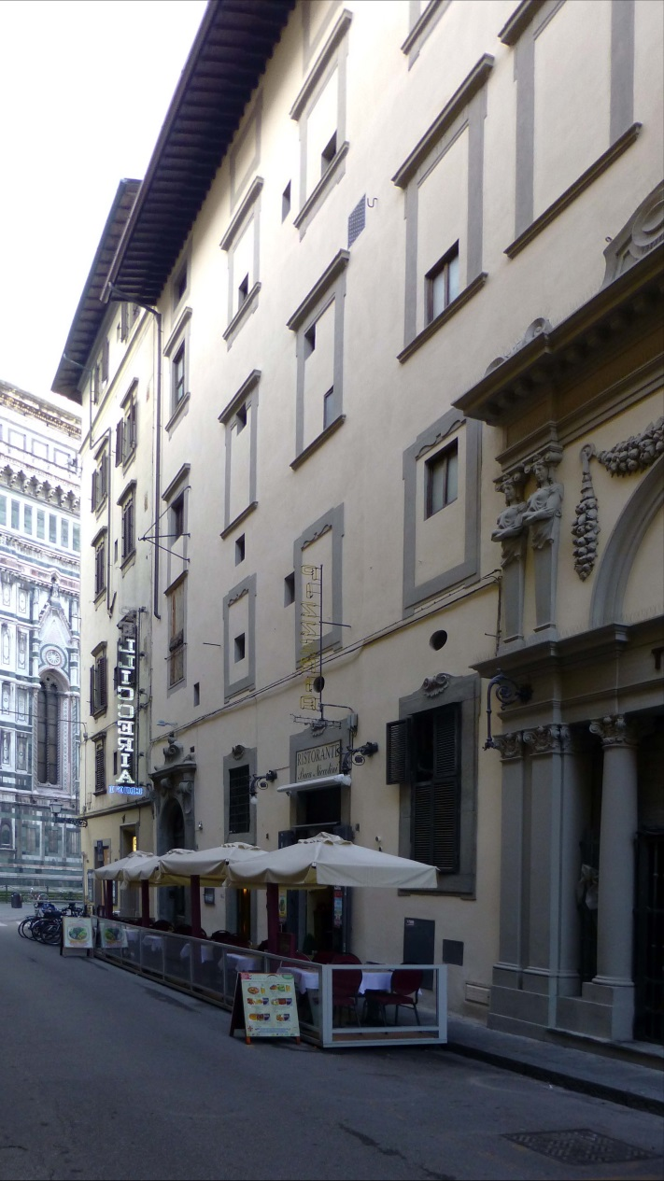

Figure 1 – Part of the façade of Teatro Niccolini, with the cathedral in the background.
Documents studied

As in the previous cases, the basis of this note has been found in different items of the TN section in the ASCFI. We have again here both registers and folders of the corresponding receipts; in this case, the new register is TN 84, a thick book of 35x24cm; the years involved are 1829-1840. Its title is Accademia degli Infuocati per il provento del giuoco. Entrata e uscita. A, and it contains 145 folios written, with further blank ones unnumbered.
As it was found in the corresponding registers previously used, also TN 84 has all the expenses for playing cards collected together under the title Spese di Carte. This occurs in folios 101, 113, 122, 124, 138.
Moreover the register TN 31, Debitori e creditori. A, already used for the previous time interval, can still provide some information on the second-hand cards sold by the Stanze up to 1840. Spese di Carte for these years are actually recorded on ff. 69, 85, and 94; however, only the first of them contains one entry with the amount of the card packs involved.
The corresponding Filza of receipts is TN 73, Ricevute attinenti all’amministrazione del provento del giuoco nelle stanze annesse all’I. e R. Teatro di via del Cocomero di pertinenza dell’Accademia degli Infuocati; this however only covers the last years, from 1 May 1837 to 30 April 1840. Another folder of receipts has been found in a different subseries, with shelf mark TN 75, Ricevute attinenti all’amministrazione del Teatro del Cocomero, del provento del giuoco e conti relativi a lavori, covering several previous years (1829-1833); for some intermediate years I could not find the corresponding receipts.

Purchases of playing cards

The kinds of cards acquired are essentially the same as before, Basse, Picchetti, and Minchiate, corresponding to packs of 40, 52, and 97 cards, respectively. We know that several cardmakers were active at the time, but we only find here Giuseppe Baragioli as supplier. Actually, in very few cases it is not certain that he had been the supplier, because the relative entry only records that the money amount had been refunded to the keeper of the Stanze, who had personally cared for the purchase.
The purchases for each year − denoted as dozen packs − have been collected together in the table below. This system of summing the packs is not present in the registers, where yearly balances may be reported, but only for the money involved in the corresponding trades.

Years | Basse | Picchetti | Minchiate | Total
1829 (part) | 42 | 15 | 27 | 84
1830 | 45 | 2 | 25 | 72
1831 | 64 | 34 | 34 | 132
1832 | 54 | 58 | 53 | 165
1833 | 39 | 84 | 49 | 172
1834 | 66 | 47 | 39 | 152
1835 | 35 | 83 | 34 | 152
1836 | 38 | 92.5 | 23.5 | 154
1837 | 17 | 84 | 24 | 125
1838 | 16 | 90 | 21 | 127
1839 | 17 | 57 | 16 | 90
1840 (part) | 0 | 12 | 4 | 16
Total | 433 | 658.5 | 349.5 | 1441

We can find a reasonable yearly average by dividing the total amounts by the eleven years concerned. We may thus deduce from the table an average value of 128 dozens (or 1540 packs) for cards acquired yearly, out of which 31 dozens (or 372 packs) representing the contribution of Minchiate. This corresponds to about 24 per cent for Minchiate, evidently still a very high fraction, comparable to the values of about 23 and 26.5 per cent found for the previous time intervals.
In terms of card packs, we had found for the years 1799-1807 (1) that the yearly consumption was of roughly 1000 packs of Basse and 300 of Minchiate. Then we found for the following years (2) values increased by about 60% for the grand total of all the packs acquired yearly, and a somewhat lower increase for Minchiate. At first sight, one might conclude that the trend is going on, without significant changes.
These average values do not provide however a thorough outline of the situation: we can understand it better if we follow the changes, year after year. Now, remarkable changes are observed, particularly for one significant point, the general decrease of the fraction of Basse packs, which were initially by far the most commonly used. Minchiate apart, Basse arrive to represent much less than one half of the playing cards used in the Stanze.
What appears as the most interesting fact is indeed the variation in the amounts of Picchetti in the course of time. In the previous years, we had seen that they were not in common use in the Stanze until about 1821. (2) By then, they appeared at once, with increasing fortune, to the point that even Minchiate suffered from an unusual strong decrease. In the following years, we assisted to a recovery of the amounts of Minchiate, and decreasing purchases of 52-card packs, after that they had reached a maximum in 1822 and 1823.
From the previous study, (2) which finished in 1829, one could reach the conclusion that the vogue of Picchetti was a passing one, flourishing in the course of a few years. Now, with the data obtained here, we can instead conclude that the vogue had only a short decline in the years around 1829, whereas in the following years, examined here, it grew again, and up to values never seen before.
It is somewhat surprising that in this instance it was the traditional Basse packs, instead of Minchiate, to suffer from the new competition. In a few years, the amount of Picchetti acquired reached that of Basse, and then Picchetti became by far the most employed packs in the Stanze.
Alongside of this competition between Basse and Picchetti, it may be surprising that Minchiate practically continued to be used in almost the same amounts. It seems that Minchiate players were a well-established group, hardly dependent on the innovations that could arrive from elsewhere. To be exact, the utilisation of Minchiate showed a general decrease in the course of time, but this decrease − except for the last years − was hardly appreciable in the time interval examined here; on the contrary, a maximum was recorded for the years 1832-33.

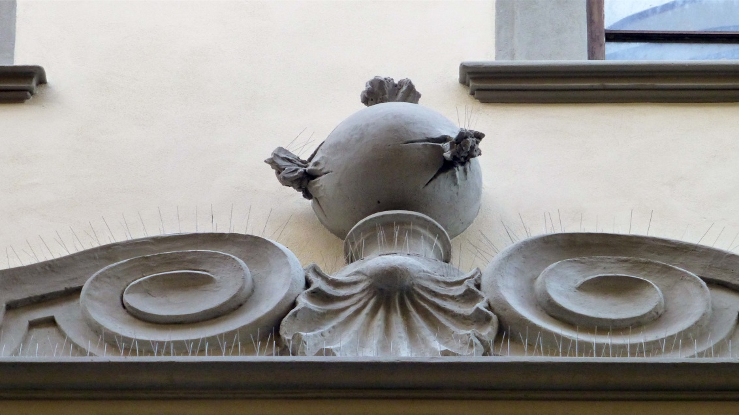

Figure 2 – The model of the Infuocati’s bomb, over the front door.

For the previous years, we had found that there was a remarkable regularity in the purchases of playing cards for the Stanze, with a prevalent number of fifteen dozen packs observed for each batch. In addition to a rather frequent purchase of 5 Basse, 5 Picchetti, 5 Minchiate, any other distribution was observed, apparently depending on the residual new packs still available of the different kinds. This behaviour is kept further in the years examined here, with greater variations in the distribution of the various kinds of packs. When a total of fifteen packs is not enough, greater amounts can be observed. Here too, however, similar changes of the distributions are observed; in several cases, a total of twenty dozens is found, instead of fifteen. This trend is easy to verify in the entries listed in the appendix.

Sales of second-hand cards

Differently from previous years, the records of the incomes deriving from selling back second-hand cards were usually inserted here without indicating the corresponding amounts of card packs. In the table below some records have been copied for the few instances with a complete information.
In the column labelled as Months, the number of past months is recorded, in which the corresponding cards had been sold back. In the Price column we find the fourth initial value for Scudi, before the “usual” L.s.d system − with one Scudo rated seven Liras.

Date | Months | Basse | Picchetti | Minchiate | Total | Price
1829-0831 | 4 | 148 | 28 | 34 | 210 | 20.5.13.4
1830-0430 | 8 | 506 | 79 | 248 | 833 | 85.1.13.4
1830-1106 | 6 | 262 | 0 | 258 | 520 | 55.5.6.8
1831-0128 | 3 | 262 |  | 177 | 439 | 46.-.3.4
… | … | … |  | … | … | …
1840-0430 | 12? | 286 | 377 | 167 | 830 | 83.-.3.4

If we limit the computation to the only data present in the table, the ratio of second-hand Minchiate to all cards sold back is found as 884/2832, or about 31% for the whole set, but evidently this set and the corresponding amounts are hardly reliable in this case. Also a comparison between cards acquired and sold back has no satisfactory basis for these years, due to the many missing records.

Card prices

For most of these trades we have the receipts, which greatly simplify our task. Actually, the unit price for one dozen packs is sometimes provided in the corresponding receipts of folders TN 73 and TN 75. It is not always present, and to derive it in other cases from the total costs of the register is not straightforward.
However, the presence of exactly the same prices indicated for some entries, both at the beginning and at the end of the time interval taken into account, allows us to conclude that Giuseppe Baragioli kept the price of his cards unaltered during the whole time interval examined.
The cost of the cards indicated in the receipts for one dozen packs was of L.13s.13d.4 for Basse, L.15s.13d.4 for Picchetti, and L.24 for Minchiate. Strangely enough, in comparison with other times, only for Minchiate we had an integer for the value of a dozen (and of a pack as well, with 2) in Liras.
These prices can be expressed in Soldi per pack, 40s. for Minchiate, and about 22s.9d. and 26s1d. for Basse and Picchetti, respectively. The last two prices are rounded off, and the fact that the price of a single pack could not be expressed with integers of Denari is a clear confirmation that they were sold by the dozens, or as other multiples, and in no case individually.
The price of second-hand cards is very seldom marked for the individual kind of cards. In a few cases, this information can however be found in the register TN 31, both at the beginning and the end of the time interval taken into account. We can read there exactly the same prices for the two boundary dates, and thus conclude that in those years the price did not change for second hand cards, as it had been found for brand-new cards.
The corresponding vales are expressed in Soldi for pack, as 16s.8d. for Minchiate, 13s.4d. for both Basse and Picchetti. The latter price is rather unexpected, because it obviously corresponds to different fractions of the cost of the respective brand-new cards. Actually, the per cent ratio of the prices of second-hand to new cards is found to be 58.54, 51.06, and 41.67 for Basse, Picchetti, and Minchiate, respectively.

CONCLUSION

Two previous studies, focused on the years 1799-1807 (1), and 1807-1829, (2) have been extended here to cover the years 1829-1840. For these years, the purchases of playing cards to be employed in the Stanze of Teatro del Cocomero have been reported, including their costs (which remain constant in these years), and discussed.
A significant number of 52-card packs appear, together with the previously used packs of Basse and Minchiate, up to ultimately becoming the cards most used. The fraction of Minchiate is still high, with around 24% as an average value for the whole period.

NOTES

(1) http://trionfi.com/ev26 : http://www.naibi.net/A/226
(2) http://trionfi.com/ev28 ; http://www.naibi.net/A/228

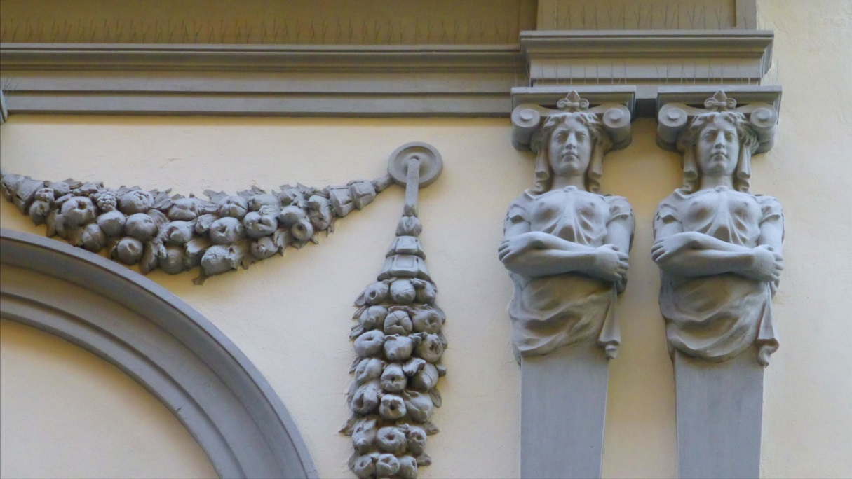

Figure 3 – Particular, from the façade of Teatro Niccolini, formerly del Cocomero.

APPENDIX − Playing cards acquired (dozen packs)

Year | Receipt | mmdd | Basse | Picchetti | Minchiate | Cost
1829 | 6 | 0718 | 30 | 15 | 5 | 109.2
 | 11 | 0831 | 0 | 0 | 5 | 17.1
 | 20 | 1107 | 0 | 0 | 5 | 17.1
 | 31 | 1231 | 12 | 0 | 12 | 64.4
1830 | 38 | 0306 | 10 | 0 | 5 | 36.4.13.4
 | 51 | 0515 | 10 | 0 | 5 | 36.4.13.4
 | 56 | 0814 | 5 | 0 | 5 | 26.6.6.8
 | 66 | 1020 | 10 | 0 | 5 | 36.4.13.4
 | 89 | 0110 | 10 | 2 | 5 | 41.1
1831 | 91 | 0115 | 10 | 3 | 5 | 43.2.13.4
 | 2 | 0505 | 10 | 3 | 5 | 43.2.13.4
 | 6 | 0425 | 10 | 3 | 5 | 43.2.13.4
 | 15 | 0531 | 10 | 5 | 3 | 41
 | 17 | 0730 | 6 | 5 | 4 | 36.4.6.8
 | 23 | 0910 | 6 | 5 | 4 | 36.4.6.8
 | 35 | 1105 | 6 | 5 | 4 | 36.4.6.8
 | 40 | 1203 | 6 | 5 | 4 | 36.4.6.8
1832 | 52 | 0126 | 5 | 5 | 5 | 38.-.13.4
 | 54 | 0208 | 5 | 5 | 5 | 38.-.13.4
 | 58 | 0315 | 5 | 5 | 5 | 38.-.13.4
 | 61 | 0413 | 5 | 5 | 5 | 38.-.13.4
 | 2 | 0605 | 5 | 5 | 5 | 38.-.13.4
 | 6 | 0715 | 5 | 5 | 5 | 38.-.13.4
 | 13 | 0901 | 5 | 5 | 5 | 38.-.13.4
 | 19 | 1006 | 5 | 5 | 5 | 38.-.13.4
 | 24 | 1109 | 5 | 5 | 5 | 38.-.13.4
 | 27 | 1206 | 5 | 5 | 5 | 38.-.13.4
 | 30 | 1226 | 4 | 8 | 3 | 36
1833 | 34 | 0123 | 5 | 7 | 3 | 35.5
 | 36 | 0215 | 3 | 6 | 6 | 39.6
 | 41 | 0316 | 3 | 9 | 3 | 36.2
 | 47 | 0412 | 4 | 10 | 1 | 33.4.6.8
 | 1 | 0510 | 2 | 10 | 3 | 36.4
 | 6 | 0611 | 2 | 9 | 4 | 37.5.6.8
 | 17 | 0805 | 4 | 4 | 7 | 40.5.6.8
 | 24 | 0914 | 5 | 5 | 5 | 38.-.13.4
 | 32 | 1109 | 3 | 8 | 4 | 37.3.6.8
 | 36 | 1123 | 3 | 6 | 6 | 39.6
 | 39 | 1220 | 5 | 10 | 7 | 56.1
1834 | 44 | 0124 | 5 | 3 | 7 | 40.3.6.8
 | 50 | 0301 | 11 | 3 | 2 | 35.-.6.8
 | 52 | 0330 | 6 | 5 | 4 | 37.1
 | 56 | 0426 | 2 | 4 | 0 | 12.6
 | 1 | 0516 | 5 | 5 | 5 | 38.-.13.4
 | 5 | 0704 | 6 | 4 | 5 | 37.5.13.4
 | 9 | 0823 | 8 | 3 | 4 | 36.-.6.8
 | 15 | 0922 | 6 | 4 | 0 | 20.4.13.4
 | 19 | 1030 | 7 | 4 | 4 | 36.2.6.8
 | 27 | 1124 | 5 | 6 | 4 | 36.6.6.8
 | 30 | 1222 | 5 | 6 | 4 | 36.6.6.8
1835 | 38 | 0120 | 2 | 10 | 3 | 36.4
 | 42 | 0223 | 3 | 9 | 3 | 36.2
 | 45 | 0316 | 4 | 9 | 2 | 34.5.13.4
 | 48 | 0413 | 5 | 7 | 3 | 35.5
 | 3 | 0518 | 4 | 7 | 4 | 37.1.6.8
 | 8 | 0720 | 3 | 7 | 5 | 38.4.13.4
 | 12 | 0824 | 4 | 9 | 4 | 37.5.6.8
 | 19 | 1006 | 4 | 7 | 4 | 37.1.6.8
 | 32 | 1207 | 3 | 8 | 4 | 37.3.6.8
 | 36 | 1228 | 3 | 10 | 2 | 35.-. 13.4
1836 | 42 | 0201 | 10 | 3 | 2 | 35.-. 13.4
 | 44 | 0221 | 3 | 10 | 2 | 35.-. 13.4
 | 48 | 0317 | 4 | 9 | 2 | 34.5. 13.4
 | 53 | 0412 | 2 | 10 | 3 | 36.4
 | 55 | 0430 | 1 | 2,5 | 0,5 | 9.1.10
 | 2 | 0501 | 3 | 14 | 3 | 47.3.6.8
 | 6 | 0704 | 5 | 10 | 5 | 49.2
 | 19 | 1011 | 5 | 12 | 3 | 46.6.6.8
 | 30 | 1212 | 5 | 12 | 3 | 46.6.6.8
 | 34 | 1225 | 0 | 10 | 0 | 22.2.13.4
1837 | 42 | 0113 | 3 | 13 | 4 | 48.4.13.4
 | 45 | 0228 | 3 | 12 | 5 | 49.6
 | 49 | 0430 | 1 | 12 | 2 | 35.4.13.4
 | 4 | 0621 | 2 | 12 | 6 | 51.2.6.8
 | 17 | 0923 | 3 | 12 | 5 | 49.6
 | 27 | 1120 | 3 | 12 | 0 | 32.5
 | 31 | 1230 | 2 | 11 | 2 | 35.2.13.4
1838 | 33 | 0116 | 2 | 14 | 4 | 48.6.13.4
 | 37 | 0319 | 4 | 12 | 4 | 48.2.13.4
 | 39 | 0422 | 1 | 6 | 0 | 15.2.13.4
 | 1 | 0514 | 3 | 12 | 5 | 49.6
 | 6 | 0710 | 3 | 15 | 2 | 42.6
 | 19 | 1001 | 1 | 16 | 3 | 49.3.6.8
 | 29 | 1203 | 2 | 15 | 3 | 47.5.6.8
1839 | 40 | 0128 | 3 | 13 | 4 | 48.4.13.4
 | 46 | 0325 | 2 | 12 | 1 | 34.1.6.8
 | 1 | 0501 | 5 | 12 | 3 | 46.6.6.8
 | 26 | 1001 | 3 | 8 | 4 | 37.3.6.8
 | 35 | 1120 | 4 | 12 | 4 | 48.2.13.4
1840 | 45 | 0203 | 0 | 12 | 0 | 26.6
 | 46 | 0301 | 0 | 0 | 4 | 13.5

