1800-1823: FLORENCE – BALANCE SHEETS OF COCOMERO
Franco Pratesi − 31.01.2014

Introduction

This note comes after several ones devoted to the same milieu. The source of the documents reported and discussed here is the same Teatro Niccolini section in the ASCFI, described in a previous note. (1) However, the object of this study is more general than in the note quoted and in several of the following ones. Instead of focusing attention into the amounts of playing-cards employed, it is expanded here to examining the whole activity of the Azienda del Provento del Giuoco, located in the Stanze annesse al Teatro del Cocomero.

The documents studied

The source for this study is just one item of the Teatro Niccolini section, namely TN 121. (2) It is a folder containing several booklets, each of them compiled as yearly account sheets for the Azienda del Provento del Giuoco. There are some scattered items for previous and later years, but most interesting is the possibility to study and compare a whole series of continuous and homogeneous yearly sheets, from 1799 to 1823. These are the documents studied here.

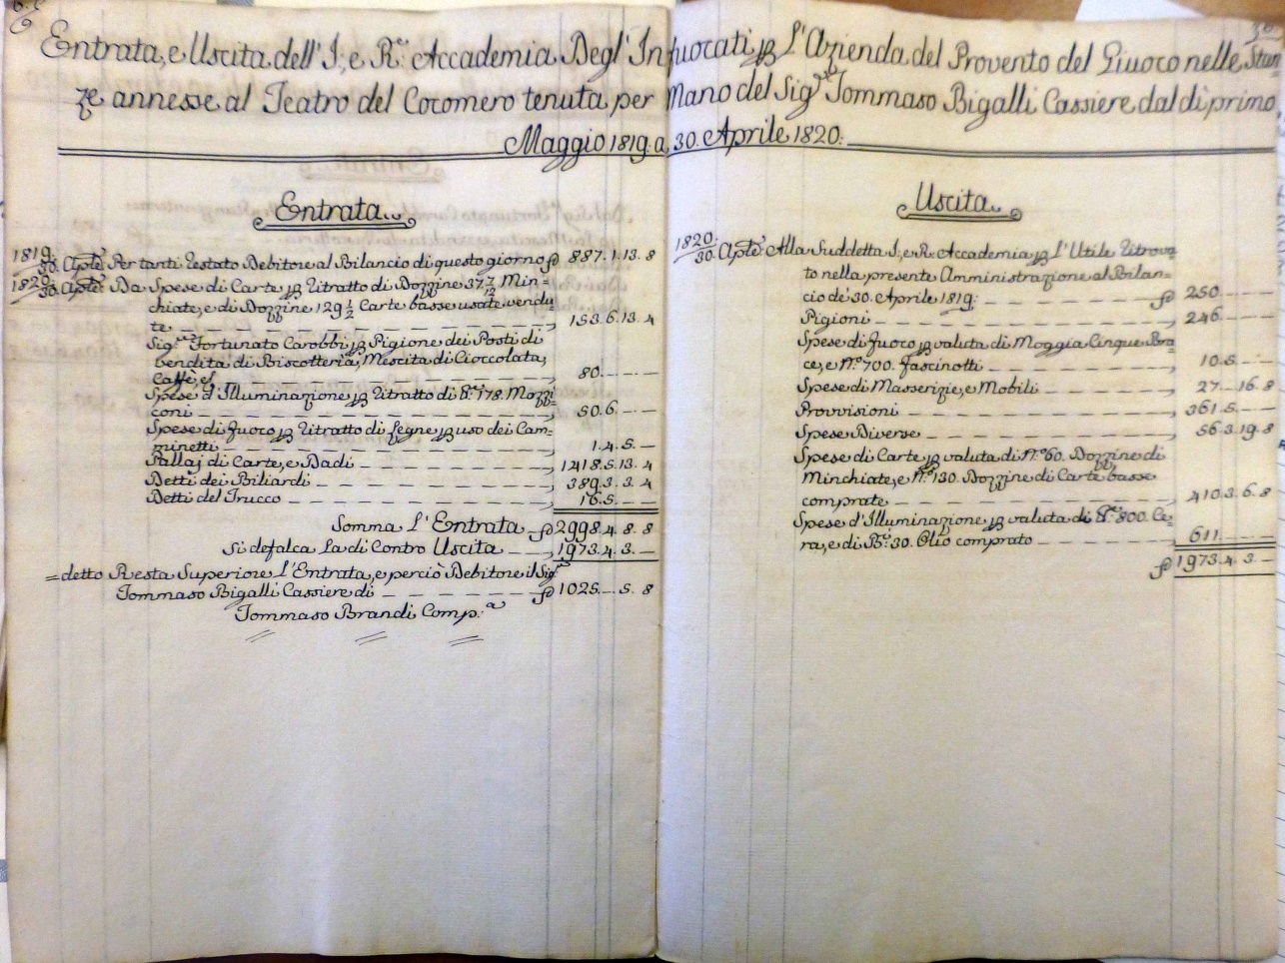

Figure 1 – Example of a balance sheet.
ASCFI TN 3 2.2 / 11 , TN 121, Anno 1819-1820. (2)
Su concessione dell’Archivio storico del Comune di Firenze. (3)

In every case the settlement of the counts was made using the 30 April as the last day of the financial year. As a consequence, I will indicate here the accounts as of the N year, but this must always be understood as the balance for the whole year that had begun on the 1 May of the previous year, N-1.
Two different systems have been used in the balances for the money units: the traditional L.s.d. up to the 30 April 1807, the “new” S.L.s.d. system for the following years; where S. Scudo is worth 7 L. − L. Lira is worth 20 s. – s. Soldo is worth 12 d. – d. is Denaro. In order to simplify the data and to make easier the comparisons
I have first decided that it was possible for our aims to neglect all fractions of Liras − expressed in s. and d. in the original records – and have then changed all the Scudi values into Liras, thus ultimately using only Liras in the following tables.
Moreover, the entries that I have copied are not all those, which are present in the original sheets. Some secondary entries, both among the incomes and the expenses, I have not copied, even if their contribution is obviously present in the total values indicated.
Just as an example of these neglected entries, I can quote the remarkable expenditure of L. 3920 recorded in the balance of 1800 for the extraordinary tax of L. 80 per day that had been imposed to all gambling houses by the French administration.

The yearly balance sheets

I could summarise all the fundamental data of the balance sheets in the two following tables, the first for the income, the second for the expenditure.

Yearly income at Stanze of Teatro del Cocomero

ANN | CAB | RIT | CAR | BIL | TRU | TOT
1800 | 700 | - | 16619 | 4170 | 390 | 22530
1801 | 700 | - | 5861 | 3439 | 463 | 11118
1802 | 700 | - | 8704 | 3914 | 871 | 14943
1803 | 700 | - | 6824 | 4015 | 810 | 12990
1804 | 700 | - | 7560 | 4143 | 711 | 13678
1805 | 700 | - | 9378 | 3696 | 662 | 15012
1806 | 700 | - | 7614 | 2923 | 409 | 12241
1807 | 133 | - | 8797 | 3500 | 691 | 14803
1808 | 322 | - | 7355 | 3598 | 636 | 11912
1809 | 322 | - | 7597 | 2985 | 622 | 11527
1810 | 175 | - | 7219 | 3799 | 480 | 11674
1811 | 262 | - | 7570 | 3751 | 666 | 12250
1812 | 350 | - | 8498 | 3430 | 288 | 12565
1813 | 350 | - | 8668 | 3141 | 260 | 12578
1814 | 350 | 476 | 9205 | 3449 | 265 | 16785
1815 | 350 | 573 | 8956 | 2994 | 337 | 17206
1816 | 490 | 69 | 7897 | 2865 | 538 | 15169
1817 | 490 | 689 | 9235 | 2891 | 1062 | 17476
1818 | 560 | 1107 | 9587 | 2923 | 750 | 19097
1819 | 560 | 1050 | 8745 | 3226 | 390 | 19474
1820 | 560 | 1077 | 9931 | 2716 | 117 | 16059
1821 | 560 | 1082 | 7663 | 3327 | 138 | 20484
1822 | 560 | 1103 | 7341 | 2684 | 131 | 13695
1823 | 560 | 1303 | 6806 | 3084 | 287 | 14425

Key: ANN, anno, year; CAB Carobbi rent money; RIT ritratto, income from used cards; CAR income from card players; BIL income from billiards players; TRU income from Trucco players; TOT total.
Yearly expenditure at Stanze of Teatro del Cocomero

ANN | GIU | ACC | PRO | ILL | FUO | CAR | DIV | MOB | TOT
1800 | 1078 | 1022 | 3060 | 4687 | - | 2204 | 680 | 1627 | 18498
1801 | 1078 | 1022 | 3060 | 3605 | - | 769 | 652 | - | 10362
1802 | 1078 | 1022 | 2898 | 5422 | - | 1158 | 1095 | 329 | 13431
1803 | 1078 | 1022 | 2948 | 5084 | - | 893 | 1216 | 61 | 12612
1804 | 1078 | 1022 | 3036 | 5977 | - | 805 | 1285 | 35 | 13300
1805 | 1078 | 1022 | 3036 | 6320 | - | 924 | 1414 | 460 | 14256
1806 | 1078 | 1022 | 3036 | 6393 | - | 964 | 1053 | 80 | 13627
1807 | 511 | 1022 | 3036 | 6346 | - | 1003 | 653 | - | 13491
1808 | 700 | 1022 | 2868 | 6025 | 28 | 1013 | 364 | 203 | 11912
1809 | 700 | 1022 | 2532 | 4408 | 42 | 1009 | 392 | 546 | 10670
1810 | 420* | 1022 | 2532 | 3807 | 38 | 1034 | 494 | 774 | 10402
1811 | 420* | 1022 | 2532 | 3937 | 25 | 1008 | 501 | 1122 | 10850
1812 | 420* | 1022 | 2532 | 4181 | 50 | 1053 | 1589 | 739 | 11867
1813 | 1722 |  | 2532 | 4362 | 45 | 1173 | 545 | 797 | 11178
1814 | 1722 |  | 2532 | 4695 | 103 | 1813 | 434 | 175 | 12877
1815 | 1722 |  | 2532 | 5052 | 97 | 1695 | 409 | 437 | 14045
1816 | 1722 |  | 2532 | 5108 | 42 | 1278 | 459 | 225 | 12298
1817 | 1722 |  | 2550 | 5485 | 35 | 2197 | 310 | 596 | 13525
1818 | 1722 |  | 2510 | 5021 | 75 | 3016 | 803 | 113 | 14313
1819 | 1722 |  | 2532 | 4754 | 40 | 2255 | 346 | 216 | 13265
1820 | 1722 |  | 2532 | 4277 | 75 | 2873 | 395 | 189 | 13815
1821 | 1722 |  | 2522 | 3983 | 80 | 2651 | 489 | 1831 | 19184
1822 | 1722 |  | 2480 | 3659 | - | 2611 | 395 | 100 | 11323
1823 | 1617 |  | 1925 | 3973 | - | 3248 | 451 | 236 | 11890

Key: ANN anno, year; GIU Giuntini rent money; ACC Accademia, rent money; PRO provisioni, salaries; ILL illuminazione, lightning; FUO fuoco, fire; CAR carte, purchase of playing-cards; DIV diverse, various; MOB mobili e masserizie, furniture and household goods; TOT total.
* together with the remaining L.280 (of the previous 700) now paid to Ignazio Francini.

Comments on the various entries and their contribution to incomes and expenses

All the values reported exactly derive from that part of the activity of the Accademia degli Infuocati, which we are interested in. As a matter of fact, we read in all these balance sheets that they belong to the Azienda per il Provento del Giuoco. The activity directly connected with the theatre – which has been considered as very interesting by the historians who have studied the documents of Teatro Niccolini − is not shown here.
Let us focus our attention into the individual entries of these balance sheets. In different years, we mostly find the same entries. It is interesting to verify if and how their values changed in the course of time.
A few of the items listed were extraordinarily constant. This mainly occurred with the rent money, both the part that the Azienda had to pay and that which entered its balance as income. If some changes occurred, they were due to real changes in the conditions.
As a remarkable example we can see the rent for Bottegone. This is a big coffee-house at the corner of Via Larga (now Via Martelli) with Piazza del Duomo. It has always been a central establishment, where the citizens could enjoy a breakfast, or a coffee break during the day. Pastry was of course always available, as well as drinks and ice-creams in the summer. It was initially part of the block that had been rented to the Accademia by the Giuntini family, and had been sublet to Carobbi, who acted as an independent barman for the Stanze.
We thus find initially an yearly income of L.700 from Carobbi; then Giuseppe Carobbi direcly acquired Bottegone from the Giuntini family, and we find he and his successor Fortunato regularly paying the rent money only for the remaining rooms, sublet from the Academy, that they still used.
In common cases, the rent moneys were the most constant entries for these balances. If a change occurred, it was either due to changes in the contract (as for Bottegone, above mentioned), or to simply changing the way of recording.
A typical example was the appearance of a S. 246 (L. 1722) yearly expenditure, which at first sight may appear as a new entry. It instead incorporated the amount of three parts for different rooms: S. 146, which was the rent money given to the Accademia in all the years considered; S. 40 to a certain Ignazio Francini; S. 60, which was the residual contribution to Giuntini.
Another entry that did hardly change was that of the salaries to the staff. In some years, we find different values; however, these were not due to any change in the monthly salaries of the employees, which instead remained absolutely constant throughout the years. If in a given year we find a lower value, this can be explained with the absence, or the retirement, of one or two employees.

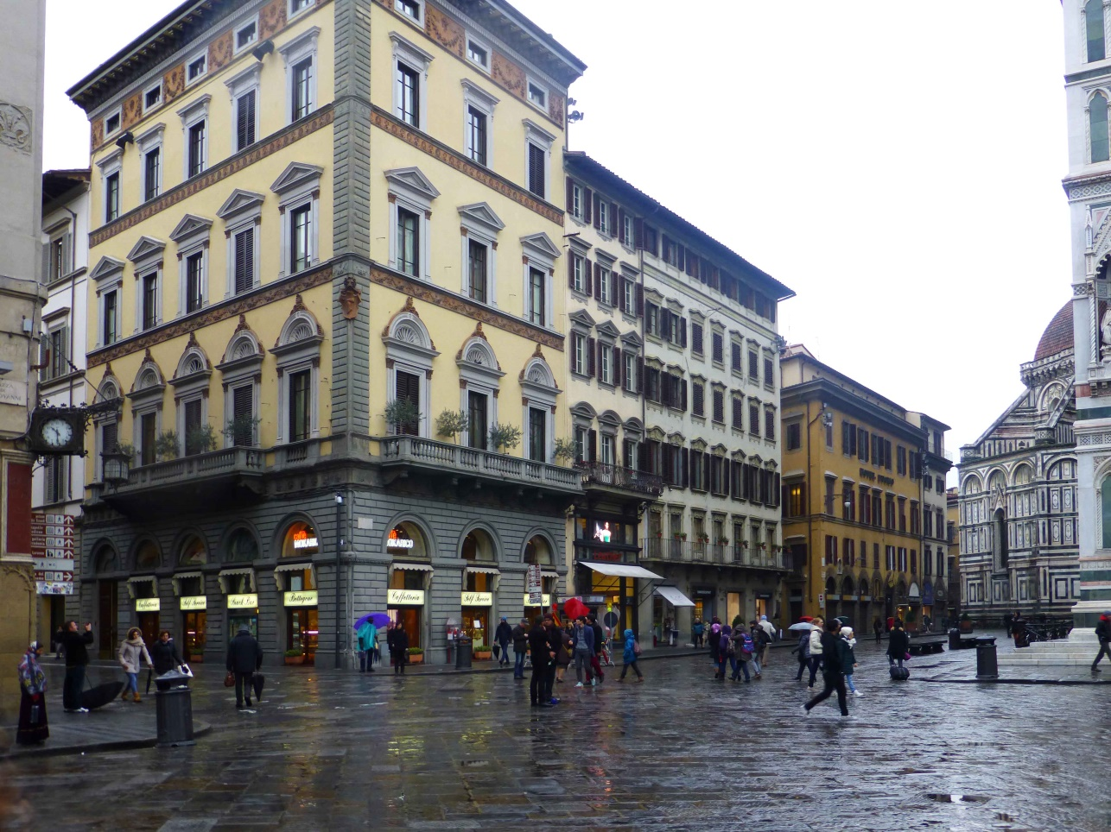

Figure 2 – The Bottegone (2014). Cocomero’s Stanze were in the street behind.

On the other hand, there were entries which could hardly be constant. In particular this condition was valid both for Spese diverse and Spese di masserizie e mantenimento. These were by definition occasional expenses, which could hardly be programmed beforehand. If a given repair was needed in a given year, the same expenditure was not present in previous or later years, at least for exactly the same amount.
Understandably, among the yearly expenses, there were specific entries for heating and lightning. It may be surprising that heating had so low costs. One has to reflect however that firewood and charcoal fire were rather cheap at the time, and were only needed for the winter months.
Lightning on the contrary was rather expensive; it formed a remarkable part of the budget and was somewhat increasing in the course of time. The chief materials were lamp oil and wax candles – with tallow as the main ingredient of the candles.
Let us now focus our attention into the parts we are most interested in, dealing with playing-cards and card games.
The returns from the games played in the Stanze formed a large fraction of the total income. They were separately recorded from card games, billiards, and trucco. Billiards in use were two. Trucco was an old apparatus, rather similar to billiards, which had mainly substituted it in the favour of the players. It is evident however that the main income came from card games.
The total income had a positive trend in the course of time, and this was largely dependent on the increase of the income from card games.

The contribution of playing cards

Playing-cards had a significant place in the section of the expenditure. The total amount paid for the cards acquired increased in the course of time. We find a difficulty in reading these values, however, due to a change in the method of recording this particular trade.
In the initial years, the cost of the cards acquired was recorded as net prices, namely having deducted the corresponding income from selling back second-hand cards. Later on, we instead find both values for new and used cards separately recorded in the two sections of the balance sheets.
In order to get better comparable values, I subtracted the yearly incomes from the sales of second-hand cards from the expenses for purchasing new cards, thus obtaining the data reported in the following table, where the net expense for cards is reported in Liras under the corresponding year.

1800 | 1801 | 1802 | 1803 | 1804 | 1805 | 1806 | 1807 | 1808 | 1809 | 1810 | 1811
2204 | 769 | 1158 | 893 | 805 | 924 | 964 | 1003 | 1013 | 1009 | 1034 | 1008

1812 | 1813 | 1814 | 1815 | 1816 | 1817 | 1818 | 1819 | 1820 | 1821 | 1822 | 1823
1053 | 1173 | 1813 | 1695 | 1278 | 2197 | 3016 | 2255 | 2873 | 2651 | 2611 | 3248

If we plot these values, the following diagram is obtained. Apart from some scattering at the margins of the curve, and especially the high initial value, we are in front of a slowly increasing function, enhancing almost linearly from one to two thousand Liras spent for cards, in the course of about twenty years. A reasonable average value can be taken as 1240L.
The most remarkable result, as far as playing cards are concerned, is the big difference of their contribution to the expenditure and to the income. Actually, they corresponded to about 10% of the expenses. For the incomes, it could not be expected that the sales of used cards were a big fraction, actually only roughly 5%. Clearly, responsible for a large part of the income were the fees that the players had to pay for taking part in the card games − for most of the time under study, this contribution reached the high value of about two thirds of the total income.

Conclusion

The balance sheets of the years 1800-1823 of the Azienda per il provento del giuoco of the Cocomero’s Stanze could be examined and discussed. Among the incomes, about two thirds came from the fees paid for card playing – billiards and Trucco contributed by far less. The net amounts paid for purchasing the playing-cards was only about ten per cent of the total expenditure – more remarkable was the fraction required for lightning.

Notes

1. www.naibi.net No. 304
2. http://archinet.comune.fi.it/
3. http://www.comune.fi.it/archiviostorico/

