CHESS AND PLAYING CARDS, Tarot included – selected opinions
Franco Pratesi, 09.08.2012

INTRODUCTION

I have recently reviewed a lot of possible sources that have been or could have been suggested for the origin of the tarot sequence. (1) One of the recent “theories”, which deals with an origin in the area of chess, (2) has only been mentioned incidentally there. Actually, something that I had to say about it can be already found in a previous article on the same subject. (3)
In the past, I have written many notes on chess history and, separately, on card history; very seldom I had the opportunity to find a link between the two subjects. Let me use this opportunity to deal with both topics together.
For connecting chess to cards, it is essential, in my opinion, to understand where (especially in Asia or Europe) and when (especially today or in the middle ages) a comparison is reasonable enough.
We cannot limit the discussion to just one part of a card pack, as is the tarot sequence; it is necessary to obtain a satisfactory knowledge of all the parts of a tarot pack, and several kinds of chessmen as well. This means that most of the following discussion will especially involve pip and court cards; the tarot sequence will only be commented on at the end of the note.

1. GAME SETS – PART ONE : Specific ASPECTS

Let us begin with some information on the game sets involved, although this matter should already be well known to everybody.

1.1 Specific features of chessmen

To describe chessmen, we have first to specify the kind of chess taken into account. Nowadays, its most typical form is international chess, in which even world championships are contested; everybody considers it as the usual form of the game. We have here a 8x8 chessboard with checquered squares, thirty-two white, thirty-two black; the pieces are similarly distinguished in two white and black “armies”, each formed by sixteen pieces. All the chessmen are rather tall pieces, not comparable with draughtsmen, and even less with playing cards.
In the initial position we have the two armies placed white in ranks 1 and 2, black in ranks 7 and 8. The two ranks used by each player are very different: in the front rank we find eight identical pawns, in the back rank the eight major pieces from a rook to the second rook, with – going towards the centre from both sides, two knights, two bishops and finally queen and king in the two central squares; clearly, sixteen pieces for each player, thirty-two on the whole. If however we count how many are the different chessmen, the result is strongly reduced, giving only six different chessmen: king, queen, bishop, knight, rook, and pawn.
After reminding this well known game, we have to consider a couple of other chess forms. Actually, many variants have been adopted in different places and times – even more versions have been invented, and hardly played for the most part. (4)
A game with little rule changes can be played on a 10x10 chessboard – this requires ten pawns on the second rank for each player and one additional couple of major pieces, one on each side, usually judges, or camels in the Islam world. As a whole, we have now forty pieces on the board.
A third form of the game that is necessary to know can be played with four different armies on the usual 8x8 chessboard. In this case, one army is placed in each of the four borders of the chessboard; they can have different configurations, but the most typical is with king, accompanied by elephant, horse, and chariot on the back rank and only four pawns in the front one. As a whole, we still have thirty-two chessmen, which must be considered however as 4x8 instead of 2x16 pieces.

1.2 Specific features of playing cards

Let us now examine how a card pack is composed; this apparently redundant information may be functional for comparing cards with chessmen. The most common pack has four suits, each with ten pip cards, numbered from 1 to 10, and three courts, jack, queen, king, for a total of fifty-two cards (jokers excluded, being a modern introduction). The cards have been quoted in order, but it is not common that this order – in principle, increasing from 1 to 13 − is respected in actual games, where some pip cards, to begin with aces, may count more than court ones.
Many reduced packs have been produced and used, with the reduction commonly involving the highest or the lowest (except aces) pip cards. Instead of 52-card packs, especially packs formed by only 48, 40, 36, or 32 cards are or have been in current use among players of different countries.
On the other hand, addional cards can be inserted into the common pack, up to reaching the 97-card pack of Minchiate. If we consider a “standard” tarot pack, we have to add its triumphal sequence of twenty-two cards, and one fourth court card in each suit, the knight, for a total of 78 cards. If we assign to each player one fourth of that amount, we end with nineteen cards. If 19 may be considered a rather unsuitable number, for Minchiate this becomes an impossible 24.25 cards.

1.3 First comparison between chess and cards

To my knowledge, correlations with chessmen have been proposed either with the pack without the triumphal cards, or with just the same additional cards. Of course, the former case has received more attention.

A) Analogies
Some analogies between chessmen and playing cards can be indicated at once. We see two obvious analogies: the first between pip cards and pawns, the second between major chessmen and court cards. Also for cards, a given suit can be considered as an army, as is more evident for chess. Pip cards are the soldiers, court cards also originally corresponded to the highest degrees of officers.
From a qualitative point of view, the analogy exists; however, it is hard to complete the correlation in a quantitatively precise way.

B) Differences
Between the two playing sets there are more, and more obvious, differences than analogies. Anybody is able to see these differences, to begin with the “transformation” from standing chess pieces to rectangular cardboards with dimensions varying in a rather narrow range around 60x90 mm.
Another evident difference is that one changes from two “armies” to four suits. Further differences can be listed, as was done for ex. by Anton van der Linde, as follows: 1) chess is a game of skill, cards imply hazard; 2) the war simulated is open in chess, hided in cards; 3) forces are exactly the same in chess, different in cards; 4) the strongest piece in old chess was the rook, which does not exist in cards − they do not correspond to aces; 5) in chess essential are the figures, in cards their numbers. (5)

C) More detail
The amounts of soldiers and officials, minor and major pieces, are not comparable. The composition of a common card pack is hardly reminiscent of chess; in particular, in playing cards we have a ratio between pips and courts that is higher than in any chess set; it is as if we had two pip cards more than necessary and five missing court cards. Also the total number of thirteen cards in each suit is not correlated with any chess army. If we pass to examine a complete tarot pack, the number if too great to be connected with any common form of chess.
If we wish to find a more precise analogy, we have to select for chess the 10x10 variant, and thus ten pip cards agree with ten pawns. What about the major pieces, however? We only have three of them, at most four in some cases, as in the tarot pack. In analogy with chess, four major pieces should better correspond to just four pip cards – too few for any matching, except in the particular case of some extant 32-card packs, in which the agreement seems to have been reached by chance, rather than following an intentional design.

2. GAME SETS – PART TWO : expanding THE HORIZON

Up to now, we had mainly to deal with chessmen and cards separately, because of the basic difference in the two game sets. Can we add examples, in which the two sets are more similar, and easier to correlate? This development is possible, on condition to leave from our countries and make a long travel towards the East.

2.1 Chessmen and chess cards from China

The correspondence between cards and chessmen may change if we extend our search to other countries, and in particular to China. In the field of playing cards and chessmen, China is not a country whatsoever. Now, every historian accepts that precisely there originated all playing cards; for chessmen, there is the alternative hypothesis of an Indian origin, but some historians accept a Chinese origin even for chess; in any case, even if we agree to its Indian origin, the spread of chess into China occurred very early.
What we have seen before for chessmen and playing cards is no longer valid in China: both sets are remarkably different from ours, and may be easier to compare.

A) Chinese chessmen
Probably more evident is the difference between chessmen. One reads that also in China they once had chessmen rather similar to ours, but since many centuries they do no longer use tall chessmen, substituted by disks of about 20 mm radius and 5 mm height. Normally, all the disks of a given set have the same dimension and are only distinguished by the symbols drawn on their upper face. I add a photo of some kinds of these disks. Probably their detail does not correspond to a current pattern of nowadays, because they were acquired in Shanghai thirty years ago.

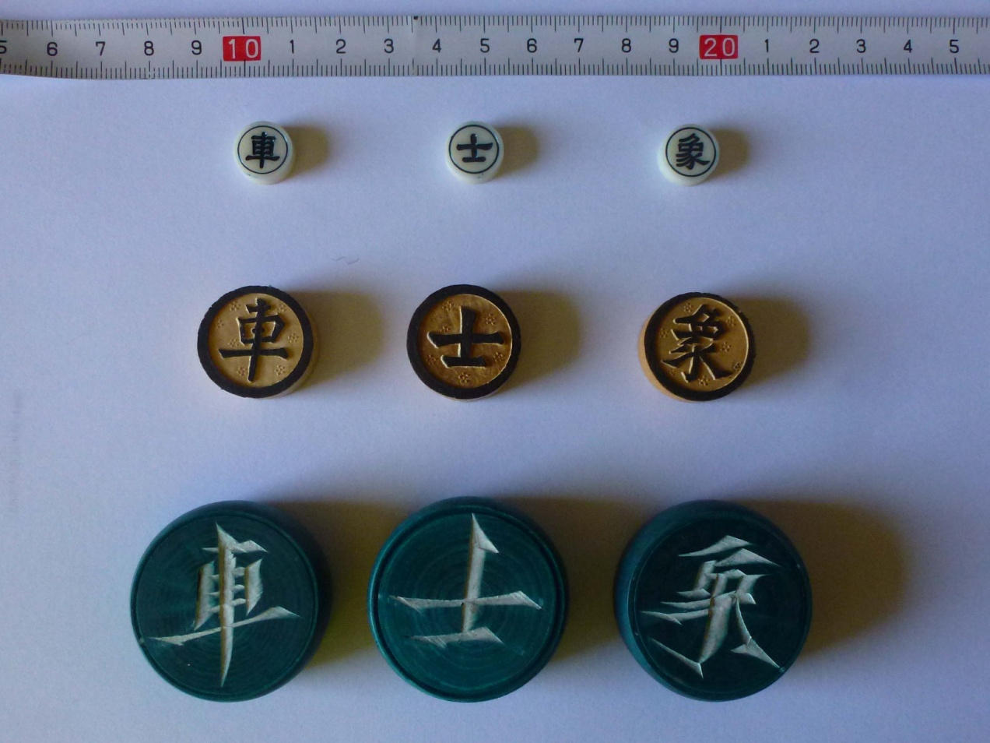

Figure 1 − Examples of Chinese chessmen from three different sets.

Another significant difference is that we no longer find here eight minor and eight major pieces, even if the total number of chessmen remains sixteen; here we have only five soldiers and eleven major pieces for each player. To note that chessmen are now placed on the intersections of the board, instead of the squares. The distribution of the major pieces on the back line is here symmetrical (as if in our chess we had eliminated queens and their column).
The central piece is now the general, and all the other major pieces are present in pairs, one on either side of it. Starting from it, we find (either advancing to the right or to the left) counsellor, elephant, horse, chariot. Two additional pieces, cannons, are located on the third line, whereas we find the five pawns on the fourth line, in one of every two places.
There are some important differences also in the power and moves of these pieces with respect to ours, but we can avoid any further detail here.

B) Chinese chess cards
If we now pass to examine the Chinese playing cards, we see pieces of paper or cardboard practically of the same thickness as our cards (actually often thinner, but this is the less evident difference). The shape of the surface is again rectangular, but these rectangles are much more elongated and smaller than ours, with dimensions varying around 20x70 mm. These cards are thus more similar to some of our tickets, of common usage for other applications, than to our playing cards.
With the same shape, or approximately the same, we have more kinds of Chinese cards, such as money cards, domino cards, and also – what is of our greatest interest – chess cards; let us limit to examine the last ones. These are cards, which are only distinguished by the chess symbols drawn on their surface, exactly the same symbols that we had found on the disks of Chinese chessmen.

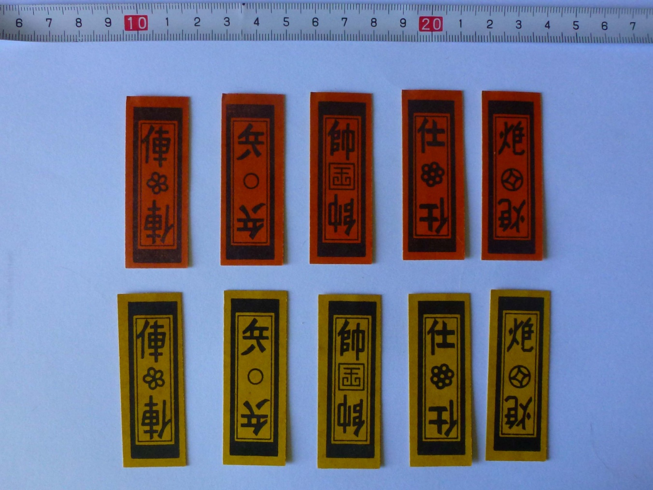

Figure 2 − Example of Chinese chess cards.

There is not a single kind of chess cards. In particular, they can be divided into two main groups, packs formed by four suits (as with our cards), and packs formed by two suits (as with our chess). «The four colours are usually white, yellow, red and green. In one type of these, each colour has four of each of the seven pieces, so a pack consists of 112 cards.»
«The two colours are usually red and black. The design of the cards varies considerably as does the number of cards in a pack. For example, there is a 112 card pack with eight of each rank in each colour, and a 56 card pack with just four of each card.» (6)

C) Comparison
The substitution of usual chessmen and cards with the Chinese correspondent items has been astoundish. We end with a completely different situation, which reminds, in our sector of card games, the game of cucu: (7) practically the same games, or at least very similar variants, could be played with the ordinary card pack, or with one of two different special sets produced only for playing this game – a special cucu card pack, or even round pieces.
The problem with the Chinese sets is however that we are not in the presence of the same game that can be played with different tools. Actually, with Chinese chess cards nobody plays chess! Even if these cards show the same symbols of the chessmen, they are used for completely different games, reminding our trick-taking games, or games of different families, which one could play with other card packs.

2.2 Tam Cúc − a Vietnamite game

Many Chinese inventions and habits have widely spread through East and Central Asia; also Chinese cards and chessmen can be found in neighbouring countries, sometimes modified in the course of time up to become particular national variants.
I intend to deal with just one case: a card set and game, typical of Vietnam, Tam Cúc, or the game of Three Chrysanthemums. It is not very different from Chinese games played with chess cards.

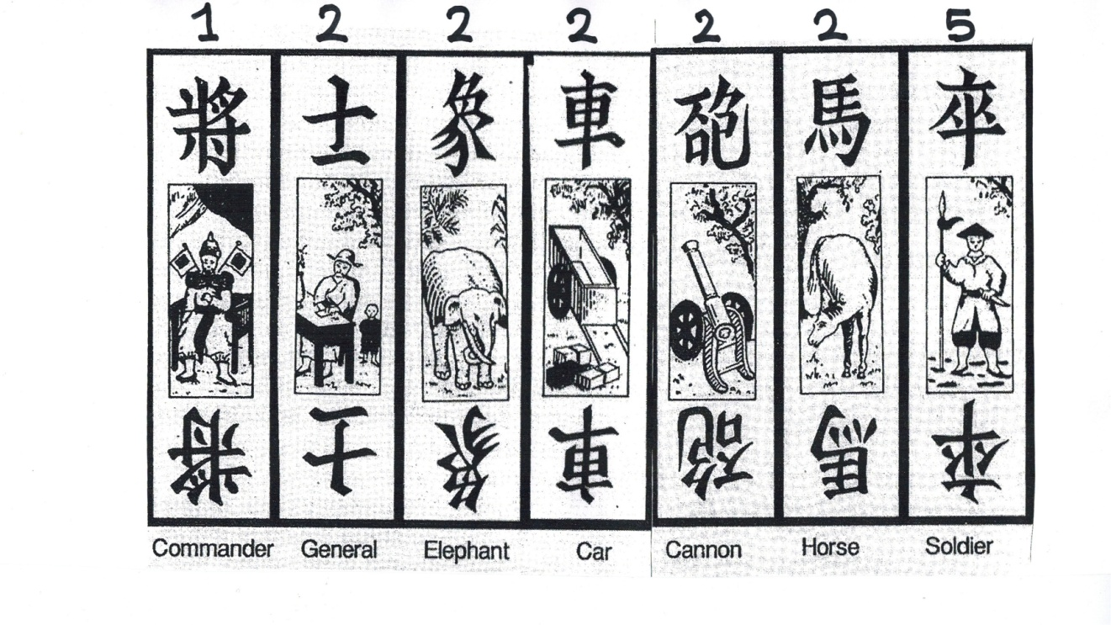

Figure 3 − Cards of Tam Cúc, from (8).
(Top numbers display identical cards in a suit.)

«The deck consists of two suits, Red and Black. The Red suit is of the same design as the Black, except that it has a red emblem stamped on top of the index that identifies the rank. Each suit consists of one Commander, two each of Generals, Elephants, Cars, Cannons and Horses, and five Soldiers. The cards rank as listed above, with Commander being the highest and Soldier being the lowest. The game of Three Chrysanthemums is usually played by four players, playing individually, not in partnerships. The basic object of the game is to win as many tricks as possible, but the play of the last trick can lead to extra bonuses.» (8)
What causes the main interest for us of this particular game is not to be found in its game rules, but just in the composition of this chess card pack. In this case, not only have all the cards the same symbols of the chessmen, drawn on their surface, but the set of cards exactly corresponds to the set of the Chinese chessmen. This card pack thus has thirty-two cards, in two 16-card suits.
For us, the importance of this example is just that card games, of a rather common character, can be played with a card pack that exactly corresponds to the pieces on the chessboard. I have no idea, whether one could also play chess, on suitable chessboards, with this set of playing cards.
In principle, this appears to be a very easy accomplishment and I am thus ready to accept any proposal that both different sets could once be used for the same game – better of course if this logical suggestion can be supported by documents too.
In any case, the two different playing tools, chessmen and playing cards, can now be considered more similar than when we had only observed them in our current games.

2.3 Comment on playing rules

In order to find a more evident analogy between chessmen and cards, we had to travel for long distances. At last, with the Vietnamite Tam Cúc, we did find a pack of playing cards that exactly corresponded to a set of chessmen. Let us now tranform this arrival into a departure for a new reflection.
While comparing chess to cards, reaching an identity of playing sets may not be enough! Basic differences in playing rules may still be kept, unacceptable for supporting a deep analogy between the two games.
Differently from chess, in using playing cards we loose the association between a given player and a given suit. Actually, I have in mind a card game, Gops, in which each of two players uses one complete suit, while the third suit is used for bidding on its individual cards, and the fourth suit is eliminated before beginning to play the game. It is a fine game, but just one and only one to my knowledge.
The difference between chess and card games is usually very great and we can see it better if approached from the chess side. Let us assume to play a card-like game with chessmen. First we have to eliminate the ordered initial position. In part, a game of this kind already exists, known as Chess960, and has been introduced by nobody less than Bobby Fischer. Here, all the major chessmen are initially placed at random, with some restrictions, in the back rank of the chessboard.
To get nearer to card playing, we have to introduce further developments: not only the major chessmen, but also the pawns should be mixed with the major pieces and randomly distributed. Moreover − and it is here that we find the essential difference − we should also forget the white-black separation of the two armies. We should place a completely random distribution of all the thirthy-two chessmen, in the four ranks available for the initial position, independent of their colour. I believe that nobody is able to play a chess game, starting from this initial position on the chessboard.

3. HISTORICAL DEVELOPMENTS

3.1 Analogies between major chessmen and court cards

Seemingly, the known transformation that chessmen had from an army to a court environment, with the new appearance of, especially, queens and bishops, was accepted for playing cards as soon as they arrived into Europe. In both cases, however, the changes were rather confuse. Here is how the great Murray summarises the situation for chess.
«We have accordingly two well-marked systems of nomenclature, the one with King, Fers, Aufin, Knight (Horse), Rook, and Pawn; the other with King, Queen, Bishop (Sage, Count, Fool), Knight, Rook (Margrave), and Pawn. If we examine the diffusion of these nomenclatures it becomes evident that the first system, which is founded on the normal laws of translation and adoption, is characteristic of the Spanish chess, and that it has extended thence with but little diminished force into the older French chess and the English game of Norman times. The second system, with its non-Muslim names, is characteristic of the German game, and to a less degree of the oldest Italian and English chess. There is an underlying unity about each set of names: the normal names carry on the Muslim and Indian tradition that chess is a war-game; the moralists discovered a unity in the new European names by regarding chess as a picture in miniature of the European state. At a later date, though still early in the European life of chess, the two nomenclatures overlapped and became confused.» (9)
Just as a special example of the mentioned confusion the situation of the bishop can be reminded. This chesspiece had the same power and moves everywhere in modern Europe but the associated character varied from a bishop (Great Britain), to a courier (Germany), an ensign (Italy), a fool (France), an elephant (Russia), and so on. If every different personage had required a different chess piece, an 8x8 chessboard was certainly not enough.
On the other hand, we find in playing cards less possibilities for a complete representation of any royal court, especially if we intend to construct it with just the court cards of an individual suit. To obtain enough personages, one should resort to some expedient, for instance associating different characters to different suits, or better involving either pip or additional cards too (see below).
If instead we search for a simulation of an army, the original form of each suit with a king accompanied by an Ober and an Unter above the pip cards (or soldiers) has been kept in some German packs, and documented in the few early Islam specimens known. However, the use of card figures as representing court characters instead of officers and soldiers has prevailed since the first records of playing cards in Europe.

3.2. Personalising pawns and pip cards

Both in chessmen and in playing cards it is not too difficult to find some analogy between either the major chessmen or the court cards and some known personage existed in one or another kingdom, in one or another time.
A different problem, seldom approached in the specific literature is what can reasonably be associated with the individual pawns or the individual pip cards. Pip cards have the advantage to be already present in a hierachical order, determined by the number itself that marks their value. This does not exist for pawns, which have no numbers and no hierarchy. In general, we don’t even try to personalise them, which historical or legendary character may be associated to each of them.
In actual play, it is not true that all chess pawns have the same power; for instance, rooks’ pawns can be considered to be weaker, because they can only capture on one side instead of two. On the other hand, the two central pawns can be considered the most important, because they can better control the central key part of the chessboard and quickly open lines to the major pieces, mostly inactive in the initial position.
It is somewhat confusing to have at the same time part of the pieces with a “meaning”, part without. Of course, in the Islam environment, there was no attempt to personalise either pawns or pip cards, due to their habit not to use figures, of anybody.
In the European environment of the middle ages, it was instead acceptable to associate original figures and characters also to the minor pieces, and sometimes this really occurred, even if any such attempt only obtained a limited success among chess and card players. (Collectors still exist, however, who only acquire old chess sets, in which pawns are different one from another.)
Let us remember two attempts of this kind in the following: both cases are the most important that come to my mind for each set. It must be said however that the chess case was much more successful than the card isolated proposal (as far as I know).

A) Jacobus da Cessole’s Moralisation
The “Liber de Moribus Hominum et Officiis Nobilium”, by Jacobus da Cessole, had a wide circulation and was copied in a great number of manuscripts of the time. Interesting is that it also brought pawns “into play”.
«The most original and remarkable feature of Cessolis’ work is his treatment of the Pawns (populares). Instead of treating them as one group, representative of the commonalty in mass, as is the general method of the moralities, he differentiates between the eight Pawns, and makes each Pawn typical of some group of allied trades or professions. By this means he is enabled to add definiteness to his picture, and to secure greater orderliness in the arrangement of the matter he had collected in illustration of the activities of the lower orders.» (9)

PAWN PERSONISATION ACCORDING TO CESSOLE (9)

1 | agricola | labourers & tilinge of the erthe
2 | faber | smythis and other werke[r]s in yron & metall
3 | notarius, lanificius, carnifex, scriptor | drapers and makers of cloth and notaries
4 | mercator | marchantes and chaungers
5 | medicus | phisicyens and cirugiens and apotecaries
6 | tabernarius, tabularius, hospes | tauerners and hostelers
7 | custos civitatis | gardes of the citees & tollers & customers
8 | ribaldus, cursor, lusor | ribauldes disepleyars and currours

It is possible that for some people (as for me) the English names of the last column are less familiar than the Latin ones to the left, but these were the names that first appeared in an English printed book. Apparently, the many pawns were not enough to represent all of the social classes and professions, which were thus sometimes put together and assigned to an individual pawn.

B) Ambraser Hofämterspiel
This “Court-office Game” is a very beatiful pack of cards, coming from Ambras castle, in Tirol.
«Each suit sign carries the coats of arms of four kingdoms: France, Germany, Bohemia and Hungary, so that, accordingly, each card carries the title of the function depicted and the respective Roman number in relation to the suit sign it represents. The illustrations, with their names written in archaic German, depict the precedence of different court functions during the late Middle Ages, together with the values of the cards, numbered 1 − 10 in Roman numerals, except for the king and queen which have no number and are also the only two subjects that do not state the character’s occupation.» (10)

Personages in the Hofämsterspiel (10)

CARD NUMBER BOHEMIA FRANCE GERMANY HUNGARY

X Hofmeister

IX Marschalk

VIII Artzt Hofmeistryn Capplan Kantzler

VII Kammermeister Schenk Truchses Kuchenmeister

VI Jungfrawe

V Valkner Koch Kellner Schütze

IIII Trometer Marstaler Barbier Trometer

III Herold Hofschneider Renner Fischer

II Hefneryn Jeger Bote Pfister

I Narr Nerryn Narr Nerryn

«In all four suits the I features a fool, Narr, or its female equivalent Narryn, and the two highest cards next to the king and queen are the master of the household, Hofmeister X, who was in charge of the court during the ruler’s absence, and the marshal, Marschalk IX, in charge of any duty that involved the use of horses or carriages. With the exception of two subjects, the Jungfrawe, card VI in all suits, and the Trometer, card IIII in Germany and Hungary, all other personages are individual and don’t appear in any other suit.»
«Therefore, what makes these cards so interesting is the fact that not only their intrinsic value for the early history of playing cards are shown, but also the evidence they provide for the understanding of the social hierarchy and everyday’s life in late medieval courts.» (10)

4. CONNECTIONS BETWEEN CHESS AND CARDS – SELECTED OPINIONS

Here, I will not try to be exhaustive, but will only report and comment on the opinions, with which I am more familiar. The opinions selected should be enough to obtain a first overview on the topic.

4.1 Opinions by Anton Van der Linde

Now, it is time to come back to our chessmen and our playing cards; that some relation could exist between these two sets has been discussed for centuries.
In the two volumes of his fundamental work, (5) which is for chess at the same time a huge bibliography and a useful history, van der Linde finds space enough for a whole chapter on playing cards, in relation to chess. This is for us a very useful review, especially because we can trust in his deep knowledge of the previous literature: we do not need to search older contributions – they cannot have escaped a mention and a critical analysis by this renowned historian.
What had already been discussed on our topic by such ancient authorities as Breitkopf, Chatto, Boiteau d’Ambly, Merlin, and Schlegel is here shortly summarised and lengthily discussed. In many places, van der Linde boasts of his superior scientific approach to historical questions, in comparison to the unfirmly based reasoning of previous authors.
Unfortunately, however, his education had mostly been based on theological learning – something rather far from any serious science – much better will be for us to find, some years later, a chess author educated in mathematics, as was Harold Murray, the greatest chess historian. (9)
The “scientific” conclusions of van der Linde are actually rather confuse. For him (as for other experts of the time) Naibi were informative cards for children, completely different from the playing cards currently used for gambling.
His opinion is already clear from the question mark in the title itself of the chapter: “Schach im Kartenspiel?” His explicit answer to this rhetoric question is of course negative: while chess actually came from the Orient, playing cards had, in his opinion, an European origin, whichever was the kind of cards taken into account, from Naibi to Tarot.

4.2 Opinions by Hellmut Rosenfeld

In Rosenfeld’s case, we have something reminding of a real theory. (11) Actually this theory does not connect with cards the standard game of chess; it is the four-handed version to be made use of. I have written “theory”, and indeed this misused term seems to me adequate in this case. Rosenfeld reflection is based on some ideas already discussed by some historians of either chess or playing cards. However, he first succeeds in building a kind of coherent and complete system.
Remarkable is the way in which he rejects some logical reasoning used by van der Linde: should we apply the same approach to our means of transport, it would be easy to prove that we first had motorcars and carriages only later on!
The longest part of his long article is devoted to prove that Naibi arrived into Europe through the Islam world. This is suggested by the name Naib that in Arab means “representative of the sultan” (as also supported by the Istanbul ancient Islam cards), by the presence of sabres as suit marks, and by the colours of the same suits.
In particular, he insists on the fact that originally the four suits did not have our two colours, red or black, but each suit had its own colour: blue for swords, green for batons, red for cups, and yellow for coins. This situation was in agreement with the fact that each of the four armies of the chess variant considered by him had its own colour as well.
After this long discussion, he has still a hard question to solve: did the cards originate within the Islam world or arrived there from countries farther to the East? His conclusion is that cards originally came from India – as it had occurred for chess − and were nothing else that a different playing tool with respect to chessmen, just a way to simplify the game. (One of the suggested motives is that the presence of a king, or Malik, in the Instabul ancient cards was not compatible with any of the real heads of the Islam world.)
Chess was a game for kings and nobles, already when the game was the four-handed version, played with dice. The two-handed version played without dice was only a later development, which required several intermediate steps and experiments, associated with gradual and irreversible improvements.
Playing cards were originally introduced as a simpler way to play chess. Actually a game of chess played with cards, no longer connected with a game board, and with cards being shuffled and distributed at random to the players, could not be the same game as used before. From a simplified version, it soon became a new game, more suitable to proliferate among soldiers and common people.
As soon as people found the way to use chess pieces without any chessboard (either to be carried or to be drawn on the floor) any soldier could bring the card pack in his rucksack and this new game version could easily spread among the common population.
Rosenfeld’s theory had some pioneering aspects for the history of Naibi, but it did not find a widespread approval, especially among chess historians. If indeed his view on the history of chess is not correct, all his bright comparison with playing cards fails at the same time.

5. FROM CHESS TO TAROT

5.1 Opinions by Hellmut Rosenfeld, again − on a new question

Everybody knows that any chess player has sixteen chessmen available; for Tarot, let us assume that the first series of triumphal cards, or one of the first sequences, was formed by precisely sixteen cards (as it indeed occurred with the first proto-tarot pack known, conceived by Marziano). Now, we find a new problem: is there any relationship between these sixteen cards and the sixteen pieces available to a chess player?
As a useful introduction to the topic, let us again resort to Rosenfeld’s expertise. In the article discussed above, he does not mention Tarot, but he extends his discussion to include the triumphal cards in another article, published ten years later in the same journal. (12) Actually, he believes that Trionfi packs were just composed by the 22-card sequence, and that Tarot precisely was born by merging into a single card pack the two different packs of Naibi and Trionfi.
However, he writes something about a possible connection of triumphal cards with chess. In his opinion, any such connection can be excluded! A connection he does introduce in the last paragraph of his article, but it is only a comparison between the similar character of the two games: the original four-handed chess played with dice, and the Trionfi or the Tarot pack. The latter, as any else card pack, is used for games in which we find a complex mixture of skill and luck, just as it had occurred in the earliest forms of chess considered by him, played with dice.
I do not remember having ever found any direct comparison between chessmen and triumphal cards, except for the recent proposal suggested by Lothar Teikemeir, which will be examined below.

5.2 Opinions by Franco Pratesi

This author has been inserted here, because it is hard for me not to agree with his opinions, as published some years ago. (3) The starting point is again the “Liber de Moribus Hominum et Officiis Nobilium”, (9) which allows characters to be associated with the simple pawns. If we try a similar approach for playing cards, some difficulty arises when distinguishing court and triumphal cards. In the triumphal sequence we find characters that are either higher or lower than those present in the court cards, and thus useful for extending the court set for providing a more realistic and complete image of a real court.
«We have to remember that, both in chess and in playing cards, a change from a military to a court representation took place. Thus, we can think to a straightforward connection with courts, and then to an extension to higher cards, following a similar procedure or environment. For instance, we can imagine (with some help from the Visconti di Modrone Tarot) a pack which has left almost no trace: plausibly only eight pip cards corresponding to the pawns, four male courts headed by the king together with four corresponding female courts headed by the queen (obviously we have here to multiply them by the four common suits, instead of two).
There are alas, several complications. To begin with, there is the lack of a similar meaning for the pip cards, which might correspond to minor personages of the court. In a socially-oriented configuration, which cards could be considered as triumphal? Obviously the highest components of social life, noblemen and so on. The problem is that most of these personages, including queens and kings, were already inserted among the “common” court cards! It is, therefore not surprising that in the triumphal cards we find even higher social figures, such as Emperor and Pope, which are present on the Earth as single specimens, as they are in the Tarot. The habit of having each king accompanied by his queen lets a wife be present both near the Emperor (even if the Empress seldom was a powerful personage) and near the Pope (and this remains somewhat surprising).
Still more surprising is the appearance among these superior cards of a couple of characters, such as the Fool and the Bagatto, which clearly appear as personages associated with a court series but not among the top cards. They look as if they belong to a series of pre-existent court cards, which included higher and lower components and afterwards was distributed among the four suits. Thus courts and triumphs were partly mixed together without producing an orderly system.
The problem is that it is impossible to consider figures such as Death, Tower, Star as extraordinary court cards. I am thus convinced that − supposing that some social and court characters were at the origin of court and triumphal cards − we can explain some triumphal cards, but not all of them and that again at least a second source has to be found out.» (3)
The last objection remains, even in case that we are able to accept the ratio of four to one for the characters present in the court cards and those only present in the triumphal series. This is already something not easy to accept: if one intends to extend the representation of royal courts within card packs, the direct ways are other ones, already discussed. Either court characters are associated to pip cards as well, or the number itself of the court cards in a given suit is augmented, typically in passing from three to four, with the presence in this case of both queens and knights, who are not present together in most of the other card packs.

5.3 Opinions by Lothar Teikemeier

Lothar Teikemeir has reflected for several months on the specific task of connecting the triumphal sequence with chessmen (and on many others as well). (2) His conclusion has been that indeed a relationship exists, as can be summarised in the following scheme, in which the triumphal cards are ideally placed on the first two ranks of the chessboard.

CORRESPONDENCE BETWEEN CHARLES VI TAROT AND CHESSMEN (2)

FOOL | MOON | SUN | LOVE | JUSTICE | TEMPERANCE | STRENGTH | FAME
TOWER | DEATH | HANGED MAN | POPE | EMPEROR | HERMIT TIME | CHARIOT | JUDGEMENT
a | b | c | d | e | f | g | h

There are interesting aspects in this proposal. For instance, a particular case is that the major pieces are present in pairs on this “chessboard”. Any chess player knows that there is a big difference between his two bishops, because one always moves on the white squares, while the other only moves on the black ones.
There is another difference that players do not mind about, but sometimes appears in the moralities connected with chessmen: one piece is good, the other is bad – exactly as in Tarot we find triumphal cards either favourable or unfavourable. As a consequence, to find bad cards on a side, good cards on the other (in the corresponding “chessboard” of the diagram above, where the triumphal cards can be placed) appears to be a reasonable answer to the task.
This result has been obtained by Lothar Teikemeier in the course of a long time; it is not an impromptu solution. In the eyes of its author, this scheme is now self-explaining, with a correspondence that should be evident to everyone. I fear that this is not the case, and that any similar correspondence can be questioned for a while, being far from self-explaining.
However, it may even not be necessary to discuss about this solution, as soon as we can be convinced that it is not the solution or the answer to be verified, but so is the task or the question itself. There can be correspondences between cards and chessmen, but this involves the whole pack, and especially the part of the tarot pack, without (!) the triumphal cards; namely, the ordinary pack as it was before the introduction of the additional cards, as discussed above.
One special point that hindered to directly compare chessmen and cards was that we have to compare four armies (card suits) with two of them (common chessmen). Not by accident, Rosenfeld chose to better compare with playing cards a four-handed variant of chess. Now, the selection goes in the contrary direction: comparing the two armies of chess with just one among the playing cards. As soon as one has found a reliable correspondence, which is the battle to simulate with just one army on the battle field?
Let us admit that any simulation of wars and battles was already forgotten at the time and we have just to represent royal courts. Four of them are already present in an ordinary pack, and each of them can be shown to have possible relations with chessmen. Now we intend to build a new representation with the cards, that of a higher court, more powerful than any royal court, in which we find one Emperor, one Pope, and we may even approach the celestial sources of their authority. Do we still need to put chess in? My impression is that here it is the task to be wrong.

Conclusion

Between chessmen and playing cards there are more or less evident analogies and differences, which have called the attention of some historians, interested in both these game sets and their history.
Any proposed interpretation has been debated, without reaching a general acceptance both by the historians of cards and those of chess. In some cases, and in particular for the task of connecting chessmen with just the tarot sequence, it is about the task itself that doubts are admitted.

Notes

(1) http://Trionfi.com/search-tarot-sources
(2)http://forum.tarothistory.com/viewtopic.php?f=11&t=788 ; http://forum.tarothistory.com/viewtopic.php?f=11&t=460&start=60
(3) Franco Pratesi, The Playing-Card, Vol. 37 (1998) No. 2, 64-68 and No. 3, 111-116. Franco Pratesi: Searching for Tarot Sources (1998)
(4) David B.Pritchard, The Encyclopedia of chess variants. Games & Puzzles, Godalming 1994.
(5) Antonius van der Linde, Geschichte und Literatur des Schachsspiels. Springer, Berlin 1874. (repr. Olms, Zürich 1981)
(6) http://www.pagat.com/class/chess.html
(7) http://Trionfi.com/cucu-cards-franco-pratesi
(8) Jude Wudarczyk, The Playing-Card, Vol XXVI No. 1 (1997) 2-8.
(9) Harold J.R.Murray, A History of Chess. Clarendon Press, Oxford 1913. (repr. 1969)
(10) http://en.wikipedia.org/wiki/Hofamterspiel
(11) Hellmut Rosenfeld, Archiv für Kulturgeschichte (1960) 1-36.
(12) Hellmut Rosenfeld, Archiv für Kulturgeschichte (1970) 65-94.

